FIO Food-In-and-Out

# VISVESVARAYA TECHNOLOGICAL UNIVERSITY BELAGAVI - 590018



## DBMS Mini Project Report on

***“FIO -FOOD IN AND OUT”***

*Submitted in partial fulfillment of the requirement for the award of the degree of*

## Bachelor of Engineering In

### Computer Science and Engineering

*Submitted By*

#### VINAYAK NAWDHAR 1DT21CS180 VIKAS JANWA 1DT21CS179 VEDANT KHANDELWAL 1DT21CS177 SHANYA SHRIVASTAVA 1DT21CS138

*Under the Guidance of*

## Prof. Shylaja B

Assistant Professor, Department of CSE



### DAYANANDA SAGAR ACADEMY OF TECHNOLOGY AND MANAGEMENT

Udayapura, Kanakapura Road, Bangalore-560082 (Affiliated to VTU, Belagavi and Approved by AICTE, New Delhi)

CE, CSE, ECE, EEE, ISE, ME Courses Accredited by NBA, New Delhi, NAAC A+

## Department of Computer Science and Engineering

Academic Year: 2023-24

1



# CERTIFICATE

Certified that the Mini Project titled **“FIO-FOOD IN AND OUT”** carried out by **VINAYAK NAWDHAR**, bearing **USN 1DT21CS180, VIKAS JANWA**, bearing **USN 1DT21CS179, VEDANT KHANDELWAL**, bearing **USN 1DT21CS177,SHANYA SHRIVASTAVA**,

bearing **USN 1DT21CS138,** bonafide students of Dayananda Sagar Academy 0f Technology and Management, is in partial fulfillment for the award of the **BACHELOR OF ENGINEERING** in **Computer Science and Engineering** from Visvesvaraya Technological University, Belagavi during the year 2023-2024. It is certified that all the corrections/suggestions indicated for Internal Assessment have been incorporated in the report submitted to the department. The Project report has been approved as it satisfies the academic requirements in respect of the Mini Project Work prescribed for the said Degree.

Prof. Shylaja B Assistant Professor Department of CSE DSATM, Bengaluru.

**Examiner 1:**

Name…………………….…….....

Signature………………………..………

**Examiner 2:**

Name…………………………….

Signature………………………….

Dr. Kavitha C Professor & HOD Department of CSE DSATM, Bengaluru.

Dr. M. Ravishankar Principal

DSATM, Bengaluru.



# DECLARATION

We, **VINAYAK NAWDHAR**, bearing **USN 1DT21CS180, VIKAS JANWA**, bearing

#### USN 1DT21CS179, VEDANT KHANDELWAL bearing USN 1DT21CS177, SHANYA

**SHRIVASTAVA**, bearing **USN 1DT21CS138,** students of Fifth Semester B.E,Department of Computer Science and Engineering, Dayananda Sagar Academy 0f Technology and Management, Bengaluru, declare that the Mini Project Work titled “**FIO-FOOD IN AND OUT”** has been carried out by us and submitted in partial fulfilment of the course requirements for the award of degree in **Bachelor of Engineering** in **Computer Science and Engineering** from **Visvesvaraya Technological University, Belagavi** during the academic year **2023- 2024**.

1. Vinayak Nawdhar 1DT21CS180
2. Vikas Janwa 1DT21CS179
3. Vedant Khandelwal 1DT21CS177
4. Shanya Shrivastava 1DT21CS138

**Place: Bengaluru Date:**

**ABSTRACT**

FIO is a food ordering platform that allows users to browse menus, place orders, and get food delivered from partnered providers. This report details the project's database design using PostgreSQL, ensuring data integrity and efficient operations. The application is built using the Next.js framework and connects to the PostgreSQL database through Vercel.Craving convenience on a busy campus schedule? FIO steps in to bridge the gap between students and their next delicious meal. This enhanced food ordering platform goes beyond simple takeout, offering a seamless and personalized experience designed specifically for the college lifestyle.

Built upon the robust Next.js framework and seamlessly integrated with a PostgreSQL database hosted on Vercel, FIO empowers students to Order with ease, Browse diverse menus, place prepaid orders, and schedule their delivery for a time that fits their busy schedules.

Say goodbye to long lines: Ditch the wait at crowded campus eateries and get food delivered directly to their dorm or preferred location.

Embrace control: Utilize prepaid orders to manage their budget and avoid impulse purchases. This report delves into the core of FIO – its database design. We'll explore how the structure adheres to strict normalization forms (NF) to ensure data integrity and efficient information retrieval. Additionally, you'll find detailed Entity-Relationship (ER) and Schema Diagrams to visualize the relationships between tables and data attributes.

But FIO offers more than just a convenient way to order food. We've also incorporated functionalities catering to administrators, providing them with valuable insights through comprehensive data analysis. This empowers informed decision-making, allowing administrators to optimize the platform and cater to evolving student needs.

Get ready to explore the intricate details of FIO's database design, user roles, and data analysis capabilities. This report will unveil the backbone of a food ordering platform that prioritizes student convenience and fosters a more efficient and enjoyable campus dining experience.

## ACKNOWLEDGEMENT

The satisfaction and the euphoria that accompany the successful completion of any task would be incomplete without the mention of the people who made it possible. The constant guidance of these people and encouragement provided, crowned us with success and glory. We take this opportunity to express our gratitude to one and all.

It gives us immense pleasure to present before you our project titled “**FIO-FOOD IN AND OUT**”. The joy and satisfaction that accompanies the successful completion of any task would be incomplete without the mention of those who made it possible. We are glad to express our gratitude towards our prestigious institution **DAYANANDA SAGAR ACADEMY OF TECHNOLOGY AND MANAGEMENT** for providing us with utmost knowledge, encouragement and the maximum facilities in undertaking this project.

We wish to express a sincere thanks to our respected Principal **Dr. M Ravi Shankar**, Principal, DSATM for all his support.

We express our deepest gratitude and special thanks to **Dr. Kavitha C,** H.O.D, Dept. of Computer Science Engineering, for all her guidance and encouragement.

We sincerely acknowledge the guidance and constant encouragement of our mini-project guide,

**Prof. Shylaja B,** Assistant Professor, Dept. of Computer Science & Engineering.

Vinayak Nawdhar 1DT21CS180

Vikas Janwa 1DT21CS179 Vedant Khandelwal 1DT21CS177 Shanya Shrivastava 1DT21CS138

# TABLE OF CONTENTS

|  |  |  |
| --- | --- | --- |
| **Chapter No.** | **Chapter Name** | **Page No.** |
| 1 | INTRODUCTION | 8 |
| 1.1 | Purpose | 8 |
| 1.2 | Scope | 8 |
| 2 | REQUIREMENT SPECIFICATION | 9 |
| 2.1 | Hardware configuration | 9 |
| 2.2 | Software configuration | 9 |
| 3 | SYSTEM DESIGN | 10 |
| 3.1 | Schema diagram | 10 |
| 3.2 | ER diagram | 11 |
| 3.3 | Table description | 12 |
| 4 | IMPLEMENTATION | 14 |
| 4.1 | User registration and login module | 14 |
| 4.2 | Admin registration and login module | 14 |
| 4.3 | User and Admin operations | 14 |
| 4.3 | Source code | 15 |
| 4.4 | Database connectivity | 19 |
| 5 | TESTING | 20 |
| 6 | RESULT ANALYSIS & SCREENSHOTS | 21 |
| 7 | CONCLUSION | 24 |
|  | BIBLIOGRAPHY | 25 |
|  | PERSONAL DETAILS | 26 |

|  |  |  |  |
| --- | --- | --- | --- |
| **SL NO.** | **TABLE NO.** | **TABLE NAME** | **PAGE NO.** |
| 1 | Table 3.3.1 | Users | 12 |
| 2 | Table 3.3.2 | Categories | 12 |
| 3 | Table 3.3.3 | Products | 12 |
| 4 | Table 3.3.4 | Providers | 12 |
| 5 | Table 3.3.5 | Orders | 13 |
| 6 | Table 3.3.6 | Order Items | 13 |

|  |  |  |  |
| --- | --- | --- | --- |
| **SL NO.** | **FIGURE NO.** | **FIGURE NAME** | **PAGE NO.** |
| 1 | Figure 3.2 | Schema diagram | 10 |
| 2 | Figure 3.3 | E R Diagram | 11 |
| 3 | Figure 6.1 | Admin login page | 21 |
| 4 | Figure 6.2 | Admin landing page | 21 |
| 5 | Figure 6.3 | User Login Page | 21 |
| 6 | Figure 6.4 | User Landing Page | 22 |
| 7 | Figure 6.5 | Upload Products | 22 |
| 8 | Figure 6.6 | Register User | 22 |
| 9 | Figure 6.7 | Cart Items | 23 |
| 10 | Figure 6.8 | Admin Order | 23 |
| 11 | Figure 6.9 | Completed Orders | 23 |
| 12 | Figure 6.10 | Dashboard | 24 |

**CHAPTER 1**

# INTRODUCTION

The FIO is a food ordering platform that allows users to browse menus, place orders, and get food delivered from partnered providers. FIO is a robust food ordering platform with a well-designed database structure that ensures efficient data management and integrity. By adhering to normalization forms and incorporating foreign key relationships, the database supports seamless interactions between users, providers, orders, and products. The provided ER and schema diagrams offer a visual representation of the database architecture, aiding in understanding and maintenance.

### Purpose:

FIO can offer a food delivery service within the college campus, allowing students and faculty to order meals from off-campus restaurants or local eateries.

Delivery personnel can use the platform to manage orders, track delivery status, and ensure timely and accurate deliveries to designated locations on campus.

### Scope:

The FIO can collaborate with local restaurants and food vendors to promote their offerings to the college community.Participating businesses can showcase their menus, special promotions, and discounts through the platform, expanding their customer base and fostering

community engagement.

Students can use FIO to pre-order meals from the campus cafeteria, reducing wait times during peak hours and ensuring their preferred items are available.

Faculty and staff members can also utilize the platform to order meals for themselves or for meetings, streamlining the catering process and improving overall productivity

Dept. of CSE, DSATM 2029 3-24 8

# REQUIREMENT SPECIFICATION

### Hardware Configuration

The Hardware requirements are very minimal and the program can be run on most of the machines.

* + - Processor - Intel 486/Pentium Processor or better
* Processor Speed - 500 MHz or above
* Hard Disk - 20 GB (approx.)
* RAM - At least 2GB
* Storage Space - Approx. 2MB

### Software Configuration

Software requirements refer to the programs, applications, and operating systems needed for a system to function. These include:

* + - Technology Implemented : Next JS framework
    - Backend Language : Javascript
    - Database : PostgreSql
    - User Interface Design : Next JS
    - Web Browser : Google Chrome, Firefox
    - Software : VS Code

# SYSTEM ANALYSIS AND DESIGN

### 3.1 SCHEMA DIAGRAM

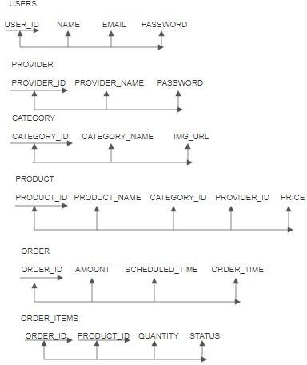

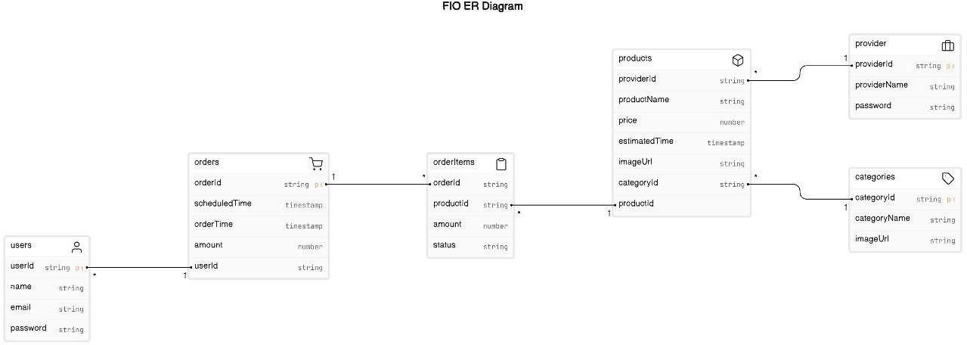

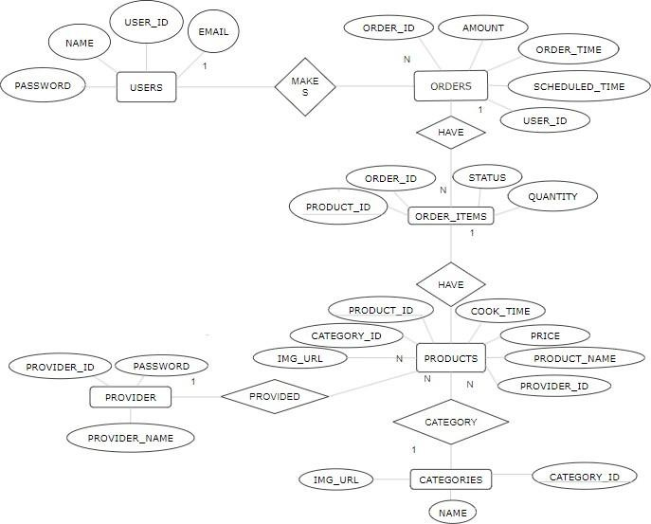

* 1. **Table description**

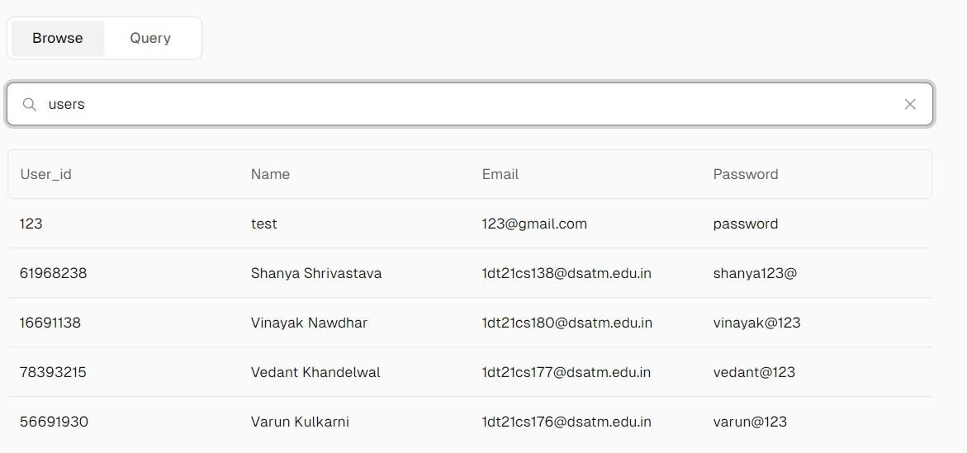

* + 1. *Fio App Database*

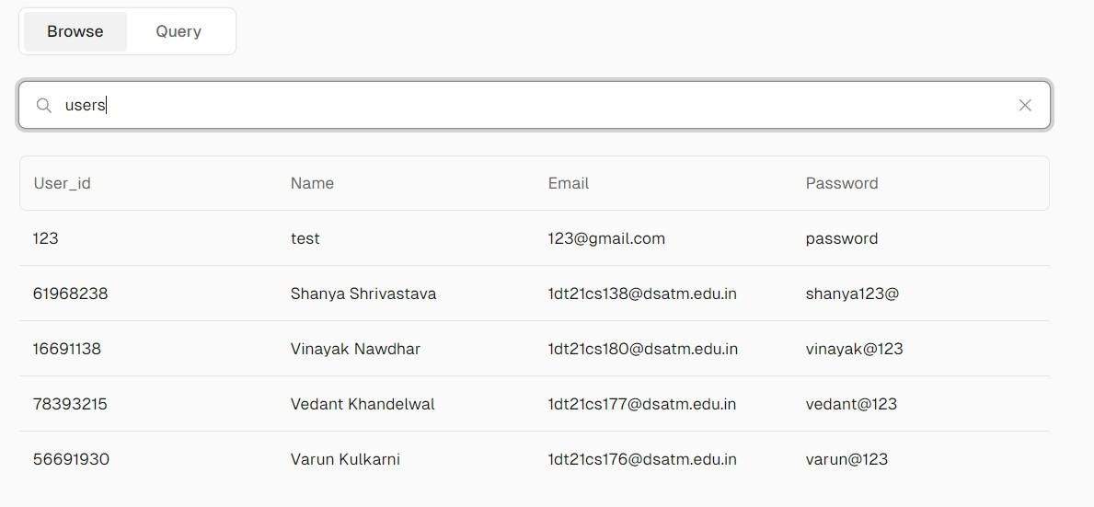

* + 1. *Users*

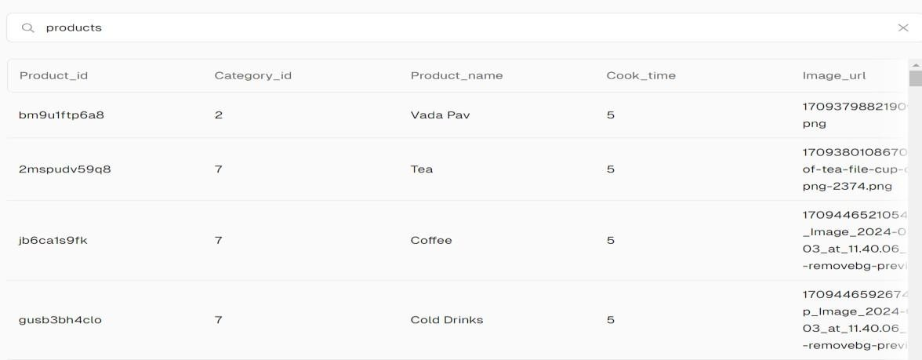

* + 1. *Products*

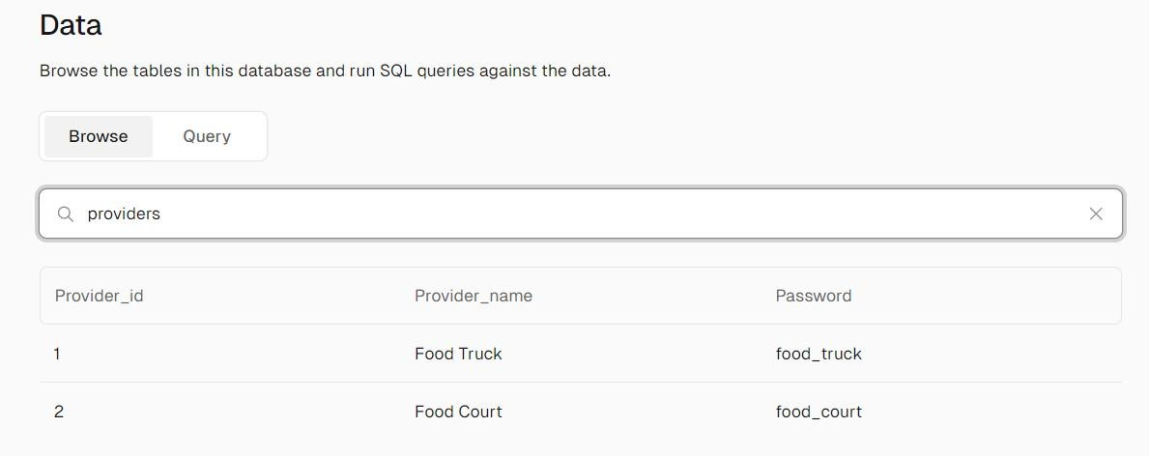

* + 1. *Provider*

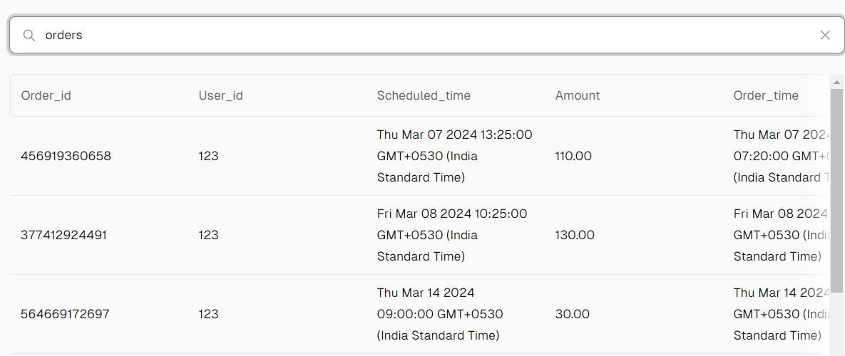

* + 1. *Orders*

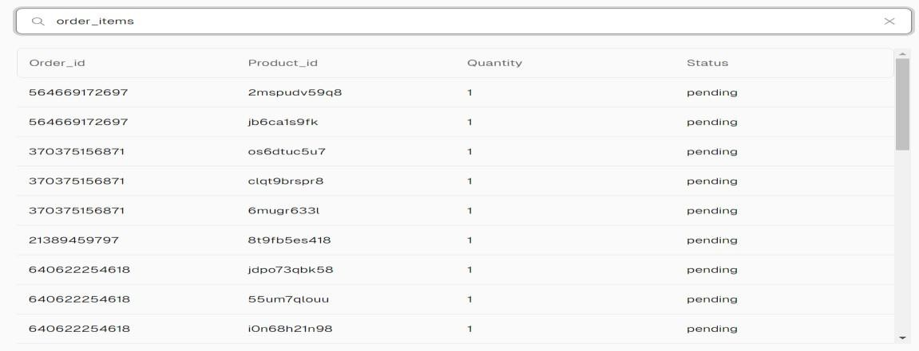

* + 1. *Order_Items*

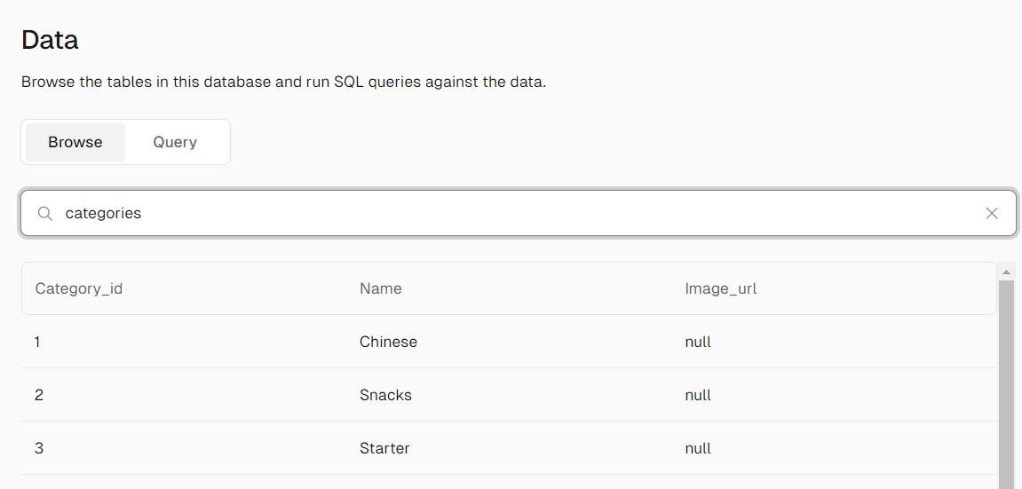

* + 1. *Category*

**CHAPTER 4**

# IMPLEMENTATION

### USER REGISTRATION AND LOGIN MODULE

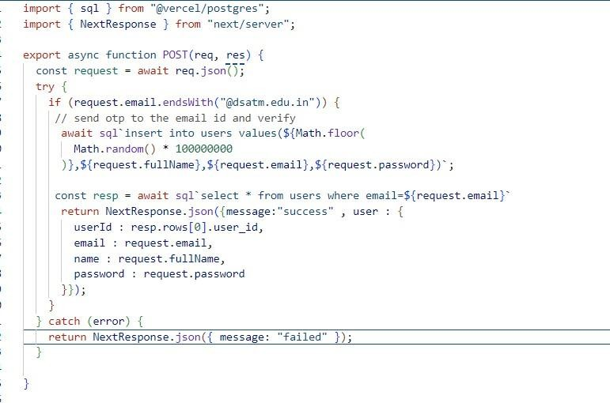

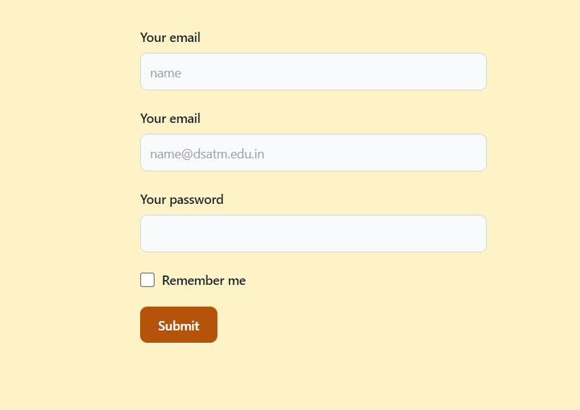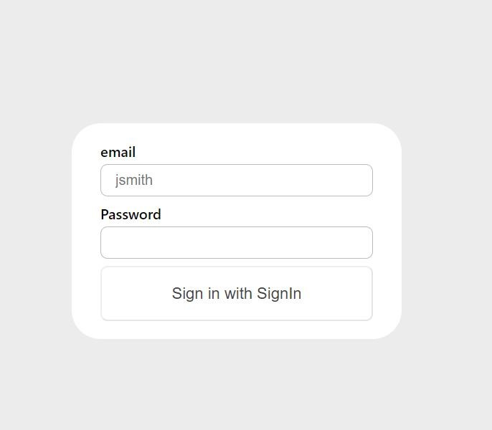

* 1. **ADMIN DASHBOARD**

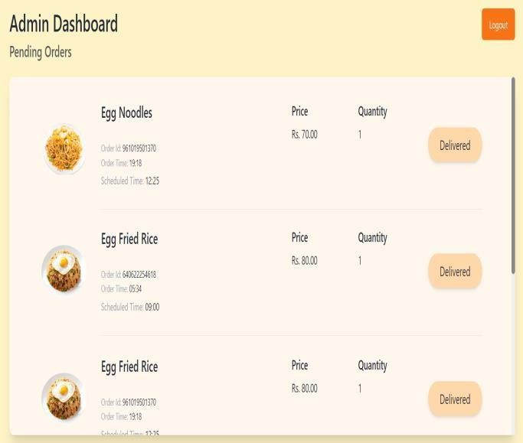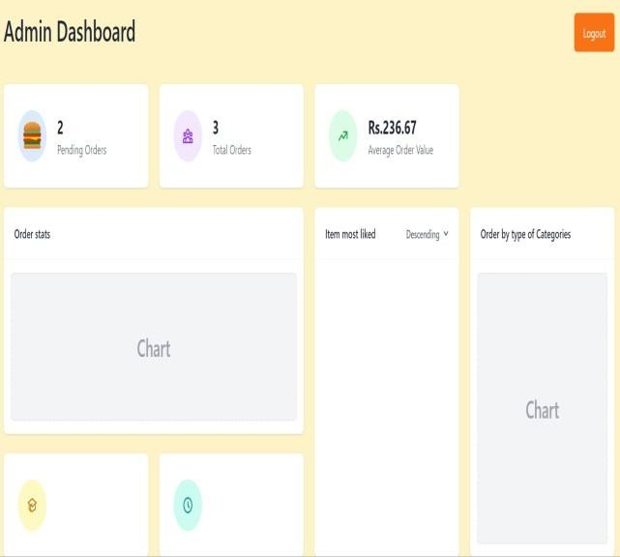

### USER AND ADMIN OPERATIONS

#### User Operations:

1. Add food items from food court & food truck items in your cart
2. User can login only using college email id
3. Users can rate their most liked product

#### Admin Operations:

1. Add new items in the following food categories.
2. They will get the count of orders,average order value in the dashboard.
3. They can check their everday sale from dashboard.
4. They can delete item which is not present.

### SOURCE CODE

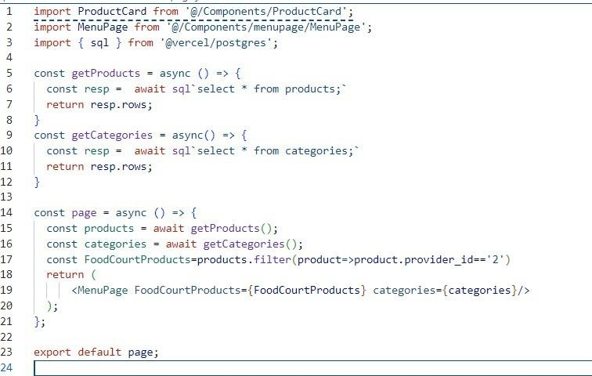

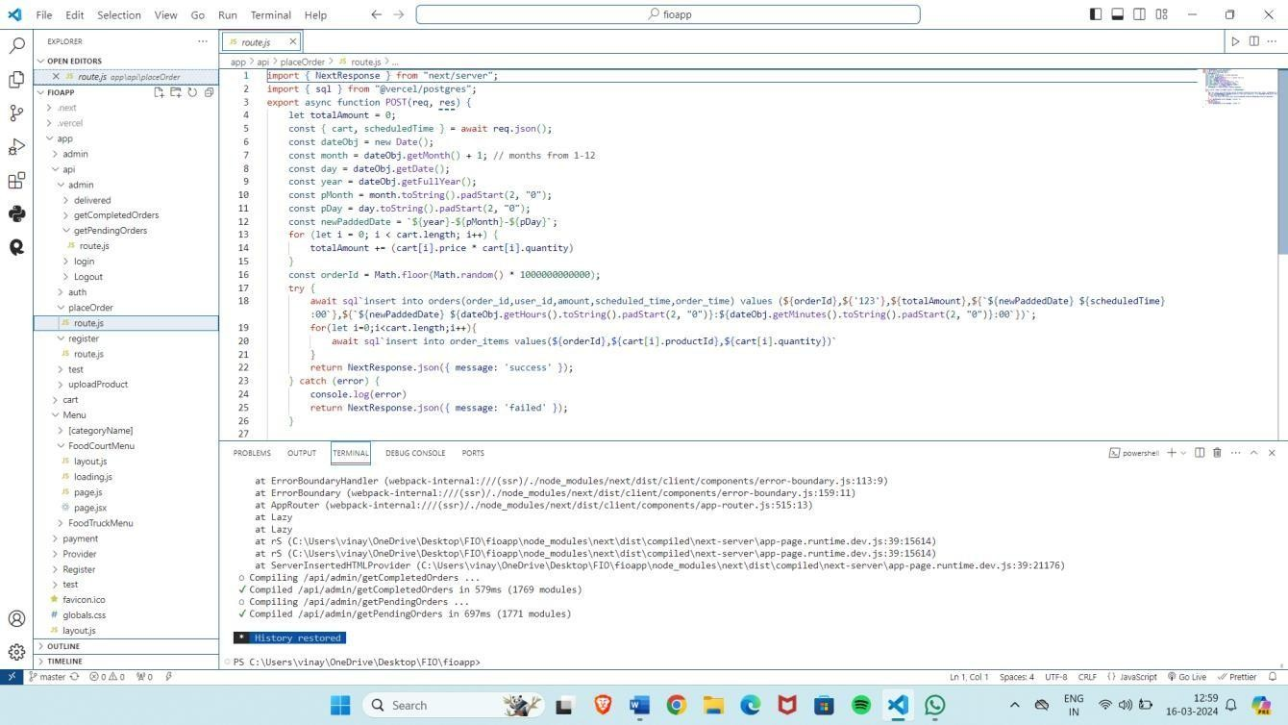

**CHAPTER 5**

# RESULT ANALYSIS AND SCREENSHOTS

### Home page

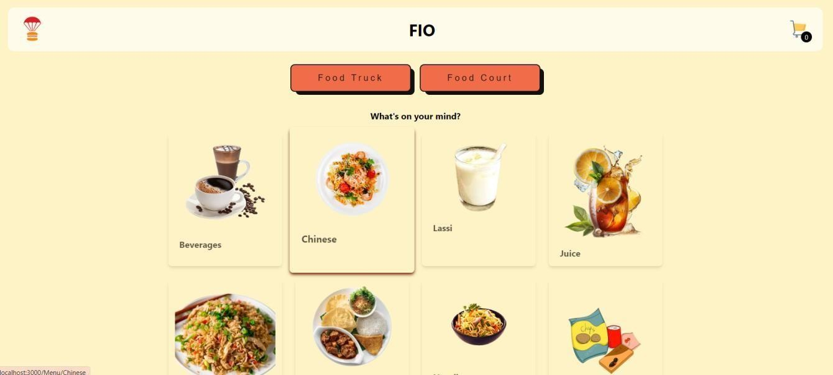

*Figure 6.1*

**Admin landing page:** An admin landing page is a web page specifically designed for administrators to access and manage various aspects of a website or application.

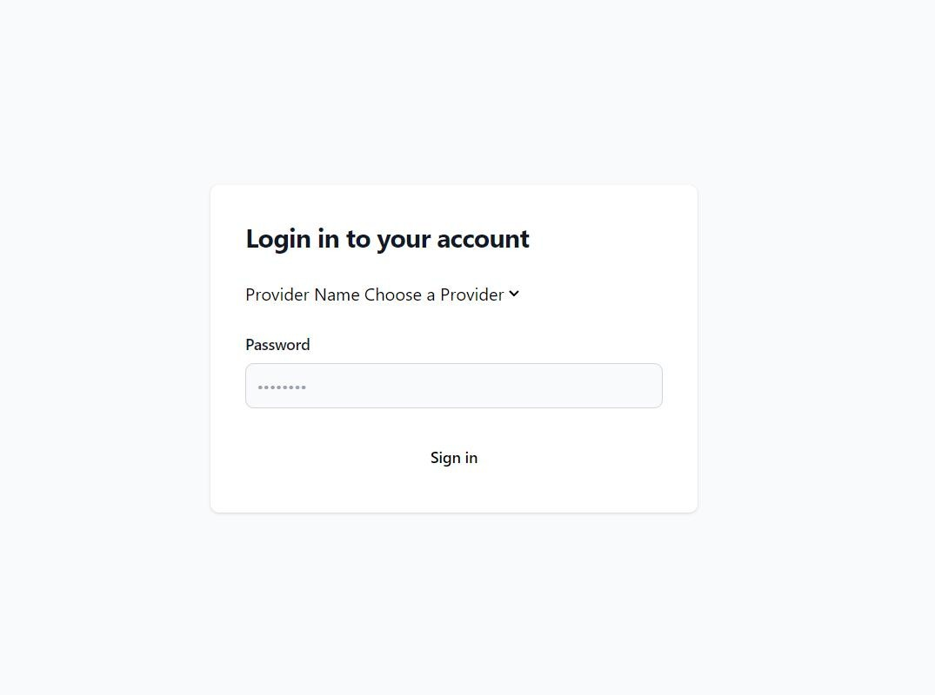

*Figure 6.2*

**Order page**: An order page is a webpage where users can view, select, and purchase productsm.

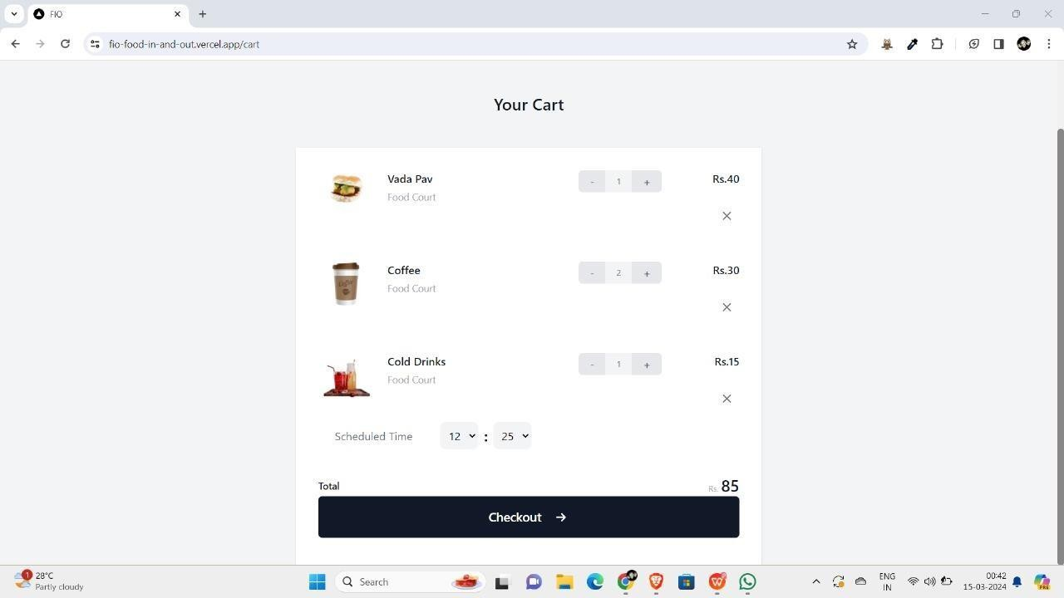

*Figure 6.3*

### Dashboard

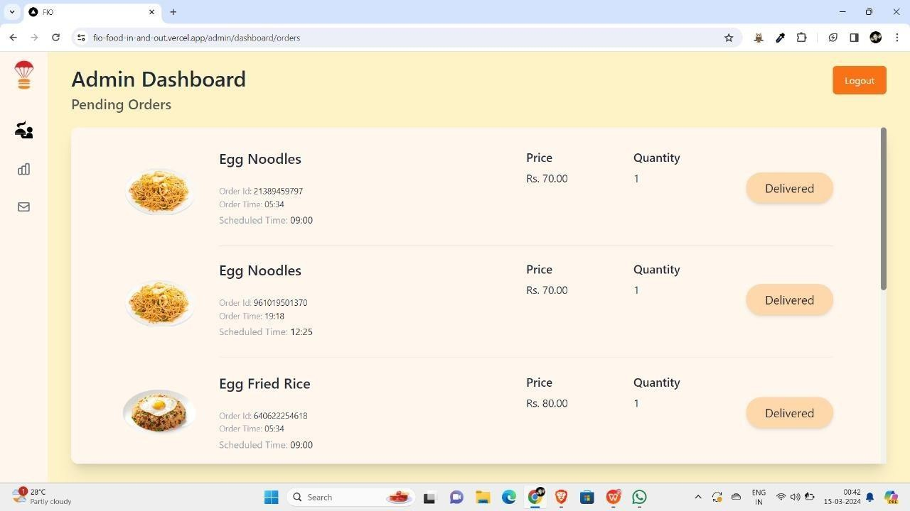

*Figure 6.4*

### Upload Products:

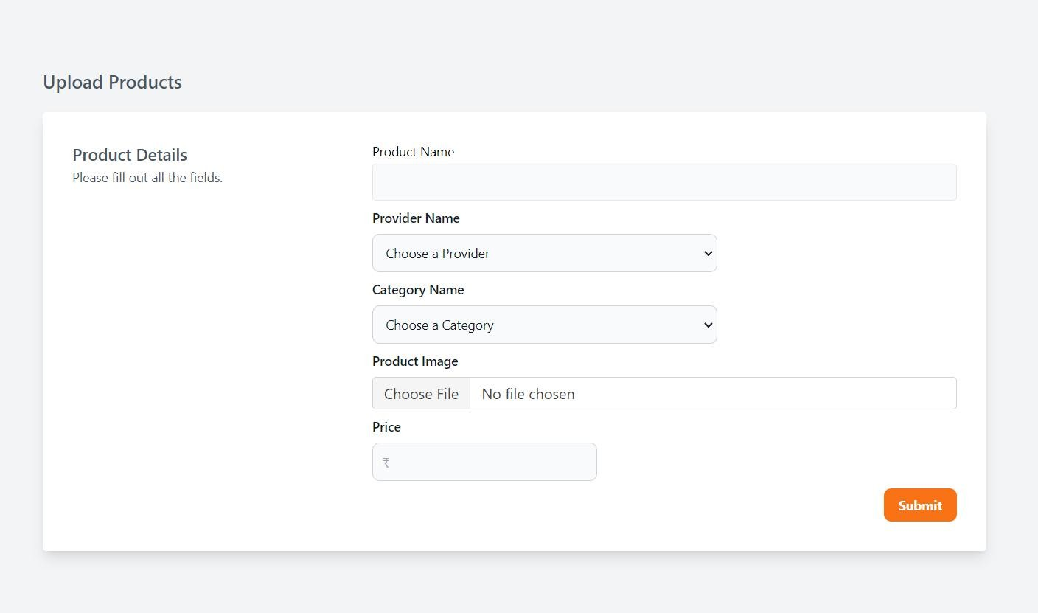

**Items**

*Figure 6.5*

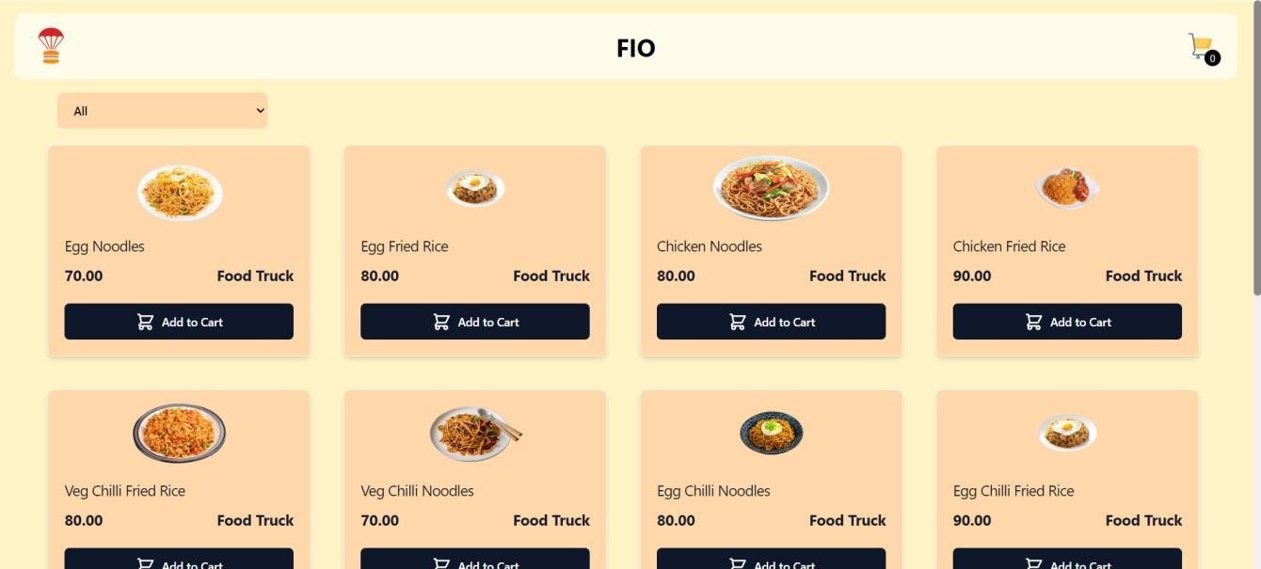

*Figure 6.6*

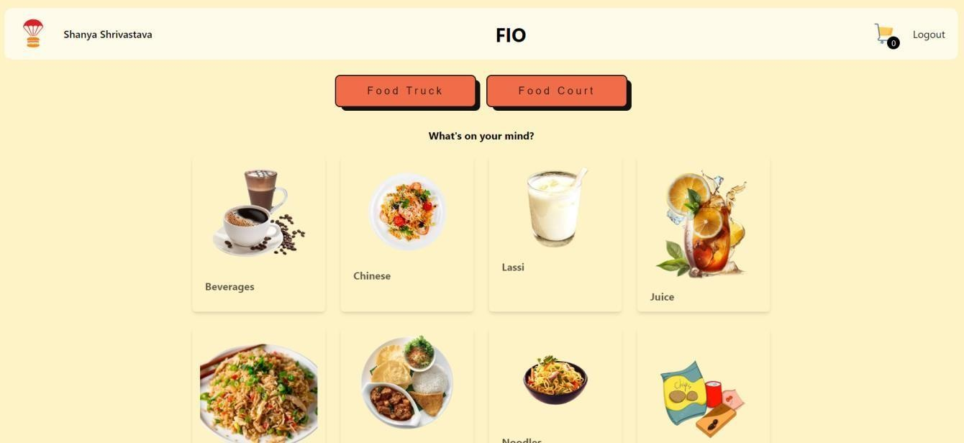**User Page:**

**CHAPTER 7**

# CONCLUSION

In conclusion, the development of a food ordering app for college canteens utilizing PostgreSQL and Next.js heralds a transformative leap forward in campus dining experiences. By leveraging the robust capabilities of PostgreSQL for data management and Next.js for seamless frontend development, this app not only simplifies the ordering process but also enhances the overall efficiency and satisfaction of both students and canteen staff.

Through the intuitive interface and real-time updates provided by Next.js, students can easily browse menus, place orders, and track their deliveries with unprecedented convenience. Meanwhile, the power of PostgreSQL ensures the reliability, scalability, and security of the app's database, guaranteeing smooth operations even during peak hours.

Moreover, this app opens up new avenues for canteen management, allowing administrators to analyze ordering patterns, optimize inventory management, and tailor offerings to suit evolving tastes and preferences. By harnessing the insights gleaned from PostgreSQL, canteen operators can foster a more dynamic and responsive dining environment that resonates with the diverse needs of the college community.

As we embrace the digital age, the synergy between technology and gastronomy redefines the way we approach campus dining. With the food ordering app built on PostgreSQL and Next.js, college canteens can elevate their services to meet the expectations of modern students, fostering a vibrant culinary ecosystem that enhances campus life and fosters a sense of community.

# BIBLIOGRAPHY

WEBSITE REFERENCE

* [https://www](https://www/).w3schools.com/
* <https://www.geeksforgeeks.org/>
* <https://speedysense.com/>
* https://[www.tutorialspoint.com/](http://www.tutorialspoint.com/)
* <https://www.phptutorial.net/>
* https://[www.javatpoint.com/](http://www.javatpoint.com/)

# PERSONAL DETAILS

Name: VINAYAK NAWDHAR USN: 1DT21CS180

Semester: 5TH SEM-C

College: DAYANANDA SAGAR ACADEMY OF TECHNOLOGY AND MANAGEMENT

Contact Number: 7250069107

Name: SHANYA SHRIVASTAVA USN: 1DT21CS138

Semester: 5TH SEM-C

College: DAYANANDA SAGAR ACADEMY OF TECHNOLOGY AND MANAGEMENT

Contact Number: 7250069107

Name: VEDANT KHANDELWAL USN: 1DT21CS177

Semester: 5TH SEM-C

College: DAYANANDA SAGAR ACADEMY OF TECHNOLOGY AND MANAGEMENT

Contact Number: 9113025037

Name: VIKAS JANWA USN: 1DT21CS179

Semester: 5TH SEM-C

College: DAYANANDA SAGAR ACADEMY OF TECHNOLOGY AND MANAGEMENT

Contact Number: 8123493822